There’s No Place Like Home: Dream Homes
We asked participants in our national housing decision-making study about where they wanted to live in the future—what their dream home would be. The study included 726 people with intellectual and/or developmental disabilities (I/DD) and family members. Here’s what we found!

WHAT ARE PEOPLE’S DREAM HOMES?
- The most popular dream homes of both people with I/DD and family members were own home or apartment, supervised group home or apartment, and home of a family member.

DREAM HOMES BY PARTICIPANT GROUP
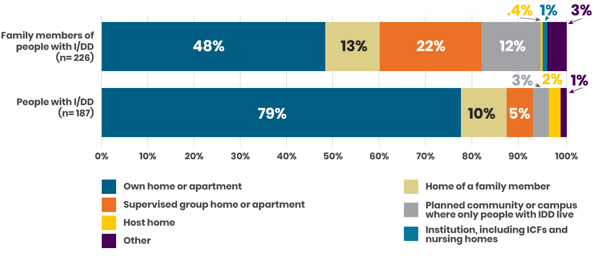
- However, people with I/DD wanted to live in their own homes (79%) much more than family members (48%).
- Family members were much more likely to want their loved one with I/DD to live in group homes, institutions, and planned communities or campuses where only people with I/DD live (35%).
In contrast, only 8% of people with I/DD expressed preference for the same types of housing arrangements.
- These differences are important because we also found that family members most often made the decision about where a person with I/DD would live.

WHAT DO PEOPLE WANT IN THEIR DREAM HOMES?
- A safe place to live
- Affordable and accessible homes
- Easy access to the community, including transportation
- Meaningful things to do during the day
- Person-centered choices about where they live, who they live with, and what they do each day
- Opportunities to make friends and romantic partners
- Good support staff who stick around
- Opportunities to learn new skills and grow independence
- Being close to family members
- The ability to have pets
- Basic amenities such as laundry
- Good relationships with roommates
- House rules that don’t limit what people can and can’t do in their own homes

Family members tended to focus on a dream home being a safe place. People with I/DD tended to focus more on having opportunities and activities, independence, and more control over their home and what they do each day—though they noted that safety was important.

KEY TAKEAWAY
We need to make it possible for more people with I/DD to live as independently as possible by making settings accessible and affordable. As we plan for future homes, we must listen to the voices and wishes of people with I/DD about what they want in a home. We must balance the need for independence, respect, and choice with a need for safety in a home.

